Liceo Max Salas Marchán
Departamento de Inglés
Guide 7: MARTIN LUTHER KING

Name: ________________________________________________________________________________ Grade: 8° A
Date: _____________June, 2020_____ Week 11

OA: Demostrar comprensión de ideas generales e información explícita en textos breves, reconociendo vocabulario clave y escribiendo información relevante usando diversos recursos multimodales que refuercen el mensaje en forma creativa en textos breves de forma guiada.

Activity 1. Read the texts under the pictures and complete them with the words from box A.
(Lee los textos que están bajo las imágenes y complétalos con las palabras del recuadro A.)

A.  Jobs and Freedom third  minister of January  assassinated speech  youngest degree | 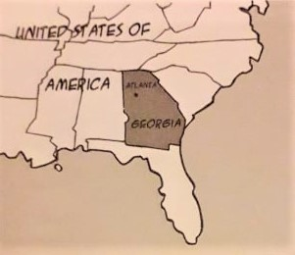 | 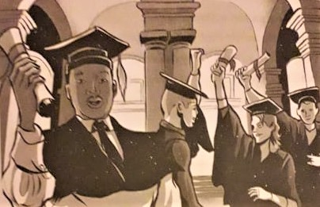
 | Martin Luther King was born on January 15th, 1929 in Atlanta, Georgia, USA. | In 1948, he gets a _____________ in Sociology and in 1951 he gets one in Theology.
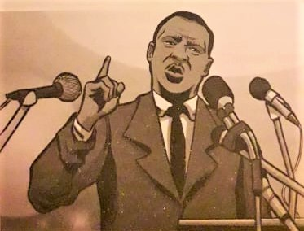 | 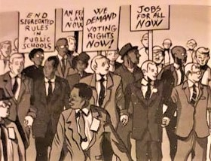 | 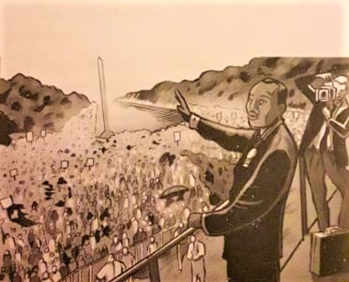
He is a religious _____________ and a leader of the African_American Civil Rights Movement. | In 1963 this movement organises the “March on Washington for _________  ___________________”, where he delivers his famous “I have a dream” speech. | He delivers his most famous ________  to over 200.000 people.
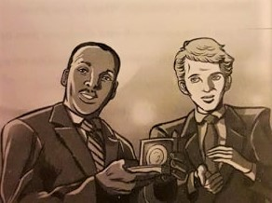 | 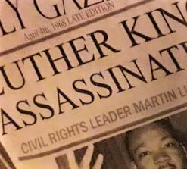 | 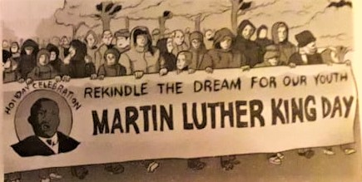
In 1964 he becomes the ___________  person to receive the Nobel Peace Prize. | He is __________________ on April 4th 1968, in Memphis, Tennessee. | In 1986 the US Government creates a national holiday called Martin Luther King Day. It is celebrated on the __________ Monday ______________  every year.

Activity 2. Match each of the words (1-8) with their definitions (A-H).
(Asocia cada una de las palabras (1-8) con sus definiciones (A-H).)

1 | civil rights |  | 8 |  | A | To disagree with somebody or object to something.
2 | discrimination |  |  |  | B | Connected to relations between people of different races.
3 | dream |  |  |  | C | A goal that somebody has, especially one that is difficult to achieve.
4 | justice |  |  |  | D | The principle of equality; the fair treatment of people.
5 | land |  |  |  | E | Unjust treatment based on category and not merit.
6 | racial |  |  |  | F | The condition of being separated, especially for racial or ethnic reasons.
7 | segregation |  |  |  | G | The rights that every person has, for example to be treated equally.
8 | to protest |  |  |  | H | An area of ground, especially when used for farming or building.

Activity 3. Each number corresponds to a letter. Solve the code and complete the message.
(Cada número corresponde a una letra. Resuelve el código y completa el mensaje.)

A | B | C | D | E | F | G | H | I | J | K | L | M | N | O | P | Q | R | S | T | U | V | W | X | Y | Z
 |  |  | 16 |  |  |  | 21

__ |  | H | __ | __ | __ |  | __ |  | D | __ | __ | __ | __ | : | __ | __ | __ | __ | __ | __ | __ | D | __
11 |  | 21 | 23 | 22 | 2 |  | 23 |  | 16 | 1 | 2 | 23 | 20 |  | 2 | 22 | 2 | 1 | 14 | 18 | 7 | 16 | 14

H | __ | __ |  | __ | __ | __ | __ | __ | H |  | __ | __ |  | __ | __ | __ | , | __ | __ | __ | __ | __ |  | __ | __ | __
21 | 23 | 10 |  | 2 | 5 | 7 | 12 | 8 | 21 |  | 25 | 7 |  | 2 | 23 | 25 |  | 6 | 23 | 25 | 2 | 1 |  | 9 | 7 | 1

__ | __ | __ |  | __ | __ | __ | D | __ |  | __ | __ | D |  | __ | __ |  | __ | __ | __ | __ |  | __ | __ | __ | .
23 | 4 | 4 |  | 4 | 23 | 5 | 16 | 10 |  | 23 | 5 | 16 |  | 5 | 7 |  | 20 | 7 | 1 | 2 |  | 6 | 23 | 1

D | __ |  | __ | __ | __ |  | H | __ | __ | __ |  | __ |  | D | __ | __ | __ | __ | ?
16 | 7 |  | 14 | 7 | 12 |  | 21 | 23 | 22 | 2 |  | 23 |  | 16 | 1 | 2 | 23 | 20

Activity 4. Unscrumble the words, then copy the letters in the numbered boxes into the grid at the bottom of the page and read the message. (Descifra las palabras, luego copia las letras sobre los cuadros enumerados en la cuadrícula del final de la página y lee el mensaje.)
DIROMTICNIISAN
   |  |  |  |  |  | 13 |  |  | 3 |  |  | 8 | 7
FEMDOER
   |  | 5 | 14
CUSJIET
   | 9 |  |  |  |  | 2
ONN - CEOLIVNE
  -
  4
RTNESGEGIAO
   |  |  |  |  |  |  | 11 | 6
CAEPE
  1
VILCI SIRHTG
   |  |  |  |  |  | 10 | 12

1 | 2 | 3 | 4 | 5 |  | 6 | 7 |  | 8 | 9 | 10 |  | 11 | 12 | 13 | 14

Te invito a ver el famoso discurso “I have a dream” en este link, solo duró 15 minutos y es considerado el mejor discurso de la historia. https://www.youtube.com/watch?v=x7C9OympYtQ&t=60s
Puedes también ver y escuchar la canción que la famosa banda irlandesa U2 le compuso a Martin Luther King.
https://www.youtube.com/watch?v=F-eOFcpUmmo
https://www.youtube.com/watch?v=oakP2DshpKE
Autoevaluación: Ahora responde estas preguntas marcando solo 1 opción cada vez.
 | Si | No | A veces
¿Conocías al doctor Martin Luther king?
¿Te gustó su discurso?
¿Te parece pertinente para los hechos que ocurren hoy en el mundo?
¿Cumpliste el objetivo de cada ejercicio?
¿Te gustó la canción Pride?
¿Te fue difícil resolver los códigos en los ejercicios 3 y 4?
Do your best! ☺
Miss Janett Sepúlveda
janettsepulveda@maxsalas.cl

