Liceo Max Salas Marchán
Departamento de Inglés

Guide 7: Best Friend
Name: |  | Grade: | 1º medio
Date : | June, 2020 | Week: | 10

OA: Demostrar comprensión de ideas generales identificando expresiones idiomáticas o combinaciones de palabras, usando material de referencia (diccionario en papel o digital, internet) para apoyar la comprensión.

Activity 1. Click on this link https://www.youtube.com/watch?v=HgvqCJjn8Mg and listen to the song, then complete the lyrics with the words from the boxes.

begins | being | breaking | calling | choosing | feel | giving | holding
keeping | know | letting | lifting | living | pretend | stand | waking

Best Friend (by Jason Mraz)  [Verse 1]  Love is where this __________  Thank you for __________ me in  I never had to __________  You've always known who I am.  [Pre-Chorus]  And I __________ my life is better  Because you're a part of it  I know without you by my side that I would be different.  [Chorus]  Thank you for all of your trust  Thank you for not __________ up  Thank you for __________ my hand  I've always known where you __________  Cause I __________ my life is better  So is the world we're living in  I'm thankful for the time I've spent with my best friend.  You're my best friend. | [Verse 2]  Thank you for __________ me out  Thank you for __________ me up  Thank you for __________ it down  Thank you for __________ us  Thank you for all you're about  Thank you for __________ me up  Thank you for __________ me grounded and __________ here.  [Chorus]  Now my life is better  Because you're a part of it  Cause I know without you by my side that I would be different.  Yes I feel my life is better  So is the world we're __________ in  I'm thankful for the time I've spent with my best friend.  You're my best friend.  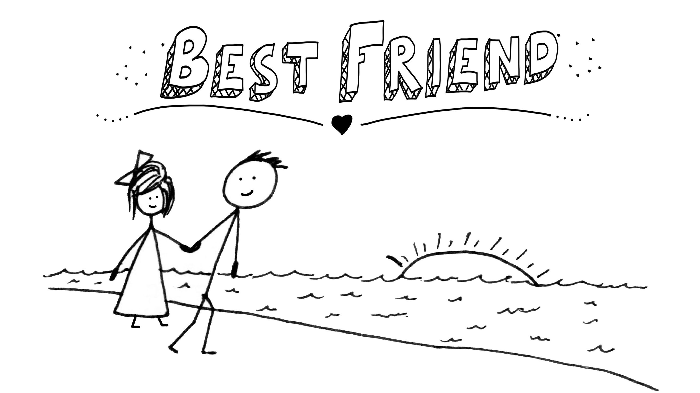

Activity 2. Now, look up the meaning of the words given and write them in the boxes next to each word.

begins | comienza | choosing |  | keeping |  | living
being |  | feel |  | know |  | pretend
breaking |  | giving |  | letting |  | stand
calling |  | holding |  | lifting |  | waking
call out |  | give up |  | let in |  | lift up
live in |  | break down |  | wake up

Activity 3. Answer the questions below.

a. What is the song about?

_______________________________________________

b. What's the title of the song?

_______________________________________________

c. What's the name of the singer?

_______________________________________________

d. Did you like the song?

____________________________________________________

Now you are ready to watch the video and sing along. Enjoy it!
https://www.youtube.com/watch?v=mBsWZzbkLMA

SELF EVALUATION: Ahora responde estas preguntas marcando solo 1 opción cada vez.
 | Si | No | A veces
¿Las instrucciones de los ejercicios fueron claras?
¿Usaste diccionario para desarrollar el vocabulario?
¿Usaste traductor para desarrollar el vocabulario?
¿Fue difícil completar la canción mientras escuchabas?
¿Pudiste desarrollar las actividades en forma autónoma?

Do your best!!! ☺

Miss Janett Sepúlveda Miss Paola Villalobos
janettsepulveda@maxsalas.cl paolavillalobosvicencio@gmail.com

