English Guide (Departamento de Inglés)

Name: Date: _________Séptima semana
Class: 4ºs Medios

Objetivo:
Reforzar la importancia del tiempo verbal ‘Present Perfect Tense’, los verbos regulares e irregulares, uso de ‘For’ y ‘Since’, para desarrollar la habilidad lectora y escrita.

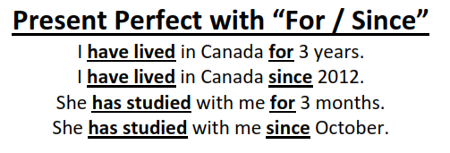

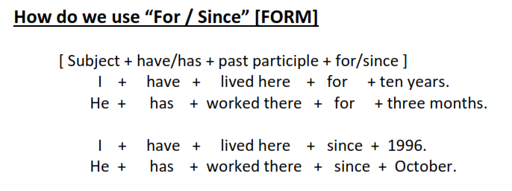
Grammar Exercise

- Put either for or since into the following sentences.

- I have lived in LG Metro City Apartments since 2006.
- He has been in my class ________ 2 years.
- They have owned that restaurant ________ I was 10 years old.
- We have played soccer on Sunday morning ________ June.
- My brother has been stronger than me _________ 3 years.
- She has been here _________ 8am this morning.
- American soldiers have been in Korea _________ 1950.
- Christmas has been celebrated ________ 700 years.

- Change the following sentences using for or since as in the examples given

If the sentence uses “for” change it to “since” and finish the sentence.
If the sentence uses “since” change it to “for” and finish the sentence.

- I’ve lived in Busan for 6 years.
→ I’ve lived in Busan since 2009.

- He’s played soccer since he was 5. (He is 15 years old now.)
→ He’s played soccer for 10 years.

- They’ve lived in Canada since June.
→

- We’ve played Minecraft for 3 hours today.
→

- You’ve sat in that seat since Tuesday.
→

- His mom has driven us to school every day for 3 days.
→

- I’ve gone jogging every morning since March.
→

- I have boiled this pasta for 20 minutes.
→

- He hasn’t seen his family for 10 years.
→

- It has smelt bad in this room for one hour.
→

- I haven’t seen you since 2013.
→

- We haven’t played computer games for 2 weeks.
→

Autoevaluación

Responde esta autoevaluación con una (X) frente a cada opción.

Sí No

- Leí y entendí el objetivo de la guía
- Leí y entendí las instrucciones de cada ítem
- Me concentré para realizar la guía en un tiempo moderado
- Me fue fácil entender en inglés cada oración de la guía
- Recurrí y busqué nuevas palabras en el diccionario
- Demostré una actitud positiva hacia el aprendizaje del idioma inglés
- Realicé la guía de manera individual y autónoma

