LICEO MAXIMILIANO SALAS MARCHÁN
ENGLISH DEPARTMENT STUDY GUIDE-Semana 9

NAME :___________________ 2nd Grades.

READING COMPREHENSION. Dear students ,you will work with this guide during two weeks, This is the first part.( Queridos estudiantes ustedes trabajarán con esta guía durante 2 semanas, esta es la primera parte.)

OBJECTIVE :Read and understand the text using previous knowledge ,identifying type of text , true or false questions and justify them.( Leer y comprender el texto usando conocimientos previos , identificando tipo de texto ,respondiendo preguntas verdadero o falso y justificándolas.)

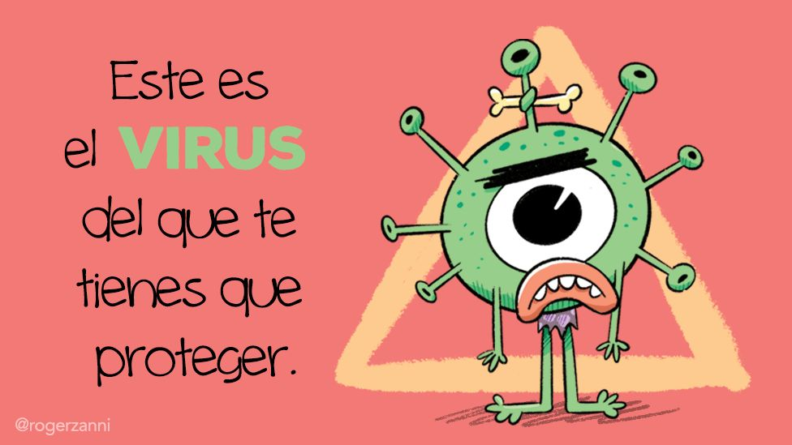
I.- DEVELOP YOUR READING SKILLS . ( Desarrolla tus habilidades de lectura).
Look at the photo , Read the text ,then do exercises. Circle the correct alternative.( Mira la foto lee el texto y realiza los ejercicios. Encierra la alternativa correcta ).
1.- The text is about : a.- a Poem b.- a Letter c.- a News .
Reading Comprehension.
Marocco on Thursday confirmed its second case of covid-19,the virus that has spread to 79 countries since it started in Wuhan, China last December.
The second person infected with coronavirus is a Moroccan citizen who return from Italy late Wednesday, the North African country’s health ministry announced.
“ The infected woman is in quarantine at a Hospital in Casablanca, and they will look after the patient.
The world health Organization declared the outbreak is an international emergency and recently updated the global risk assessment to “very high”.It
Has also advised the public to wash their hands more than the usual besides delaying or avoiding travel to affected areas.
Commom signs of the infection include fever , cough , shortness of breath and breathing difficulties.
Anadolu News Agency.

2.- Are the following statements true or false ? Justify !
a.-The second Moroccan citizenwho is infected with the virus came from france. ______________________________________
b.-Inability to sleep is one of the virus’s symptoms.
_________________________________________
c.-People can travel wherever they want despite the widespread virus.
________________________________________________.
Vocabulary
Citizen : ciudadano , look after : cuidar outbreak :brote
Updated : actualizado, risk assessment: Evaluación de riesgo , cough: Tos
Shortness of breath : dificultad para respirar , breathing difficulties: dificultades respiratorias.
Subraye las frases que estén en Presente perfecto.Lei
Autoevaluación .

Responda esta autoevaluació colocando una( X) donde Ud. estime que corresponda, ésto nos ayudará en la retroalimentación.
Sí No
1.-Leí y entendí los ejercicios de la guía ____ ____
2.-Las instrucciones eran claras y precisas ____ _____
3.-Me pareció interesante la lectura ____ _____
4.-Ocupé mucho tiempo en realizar la guía ______ ______
5.-Mi actitud fue positiva hacia el aprendizaje
Del idioma Inglés. ____ _____

I.-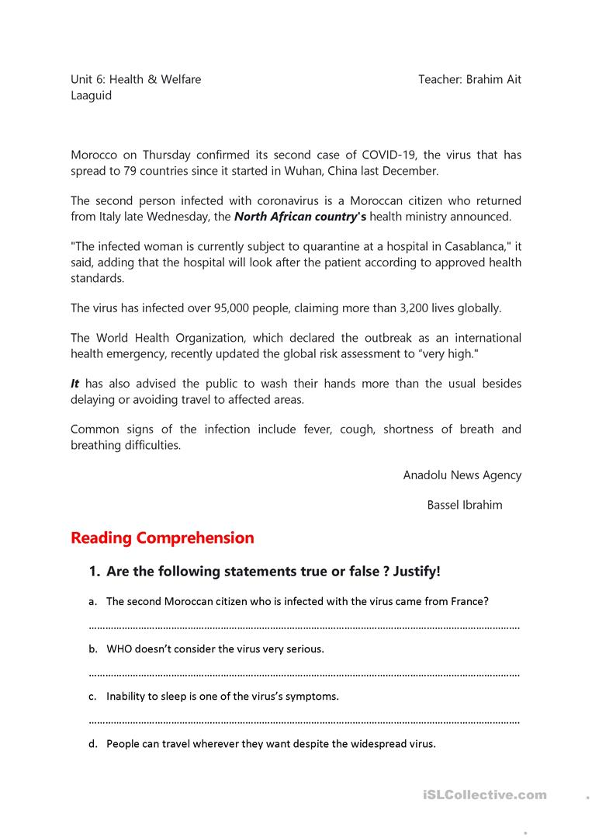g text and do some exercises.
A.-Look at the photo and circle the correct alternative:(mira la foto y encierra la alternativa correcta.)
- Party concert walk coronavirus
B.-this texts is :
a poem a News an Article a letter
C.- Write :true cognate or false cognate next to the word. Remember ¡!!!...
True cognates are words that are similar, or even identical , in two languages ./ Los verdaderos cognados son palabras similares e incluso idénticas en dos idiomas.
Examples: English--- capital Spanish ---capital
English – banana Spanish – banana
English--- imposible Spanish ---imposible
False cognates ( false friends) / Falsos amigos.are words that have different roots but have the same meaning
Examples : English :carpet Spanish : alfombra (confused with,carpeta
English : choke Spanish : estrangular( confused with choque

What are coronaviruses?
Coronaviruses were discovered in the 1960s. They are a group of viruses that cause diseases in mammals and birds. In humans, coronaviruses cause respiratory tract infections that are typically mild, such as the common cold.
The name "coronavirus" is derived from the Latin corona, meaning crown or halo. The name refers to the characteristic appearance of the infective form of the virus, which is reminiscent of a crown or a solar corona.
The new coronavirus
At the end of 2019, a new type of coronavirus started spreading in China. This type of coronavirus is often called 2019-nCoV, novel coronavirus, or COVID-19. It is believed that the virus was transmitted from animals to humans. Some of the first cases were diagnosed in people who had visited a market selling live seafood and animals. Unfortunately, when viruses are transmitted from animals to people, it can take scientists a lot of time before they can develop a vaccine or medicines to cure it.
The symptoms of the new coronavirus
Some of the symptoms of the coronavirus are fever, cough, runny nose, sore throat, headache, and trouble breathing. These symptoms are very much like those people have with a cold or the flu. The virus can be more serious in some people, especially if they are sick or have health problems.
While it is early to have a definite picture of the disease because scientists are still collecting the data, some patterns have already emerged. Some early reports reveal that children seem to be getting coronavirus at much lower rates than adults. Even if they get infected, the symptoms are milder. However, most people who get severely infected are those with a weak immune system, like the elderly. Coronavirus may be life-threatening for these people. They may develop more serious respiratory tract illnesses that may be fatal.
How does the virus spread?
The virus appears to spread mainly from person to person. The transmission occurs when someone comes into contact with an infected person. For example, a cough, sneeze or handshake could cause transmission. The spread may also be caused by coming into contact with something an infected person has touched and then touching your mouth, nose or eyes.
Treatment
There is no specific vaccine or medication to cure the disease, but generally, symptoms will go away on their own. However, experts recommend seeking medical care early if symptoms feel worse than a standard cold. Doctors can relieve symptoms by prescribing pain or fever medication. As far as antibiotics are concerned, they are useless to treat coronavirus.
People who think they may have been exposed to the virus should contact their healthcare provider immediately. A set of preventive measures are usually followed in case someone gets infected. This includes keeping infected people in quarantine for a certain period, generally fourteen days.
How to protect yourself from coronavirus?
To protect yourself from the virus, here are six recommendations to follow:
- Avoid contact with people who are already infected.
- Wash your hands well and regularly for at least 20 seconds with soap and water or use hand sanitizer.
- Avoid touching your eyes, nose, and mouth if you haven't washed your hands.
- Clean and disinfect surfaces and objects that people touch a lot.
- Stay home when you are sick.
- Cover your cough or sneeze with a tissue, then throw the tissue in the trash.
Sources: Wikipedia

Comprehension:
- Coronaviruses were discovered in 2019.
a. True
b. False
- The source of the coronavirus probably comes from animals.
a. True
b. False
- Children get infected more than adults
a. True
b. False
- Doctors prescribe antibiotics to treat the coronavirus.
a. True
b. False

Related materials:
- The coronavirus
- The common cold
- Factors of good health
- Health tips
- Vocabulary related to health
- Quotes about health
- Jokes about doctors

Quick Links
Grammar Lessons Vocabulary Lessons Speaking Lessons Reading Lessons Writing Lessons Listening Lessons Exercises and Quizzes
Awsome Links You May Like
- A List of Idiomatic Expressions
What are idioms? And how can idioms help you become a fluent speaker? Discover a list of the most widely used idiomatic expressions!
- A list of Phrasal Verbs
Phrasal verbs are generally used in spoken English and informal texts. Check out our list of hundreds of phrasal verbs classified in alphabetical order.
- A list of figures of speech
Do you want to provide emphasis, freshness of expression, or clarity to your writing? Check out this list of figures of speech!

English For All
Free English Grammar Lessons and Exercises
SUBSCRIBE TO RECIEVE OUR NEWSLETTER

Study Pages
- Grammar
- Speaking
- Vocabulary
- Reading
- Listening
- Writing
- Phrasal verbs
- Idioms
- Exercises
- Figures of speech
- Study Skills
- Global tests
- Literature
- Dictionaries
- Holidays
- Site news
- World news
- Studying in the USA
- Visit the world
- ELT books

Teachers
- Resources
- Shared resources
- Teaching materials
- Blog
Learn English the fun way

