GUÍA DE REFORZAMIENTO INGLÉS N°2
IRREGULAR VERBS

SEGUNDOS MEDIOS

- A continuación te mostraremos la regla gramatical que se emplea para los verbos irregulares, junto con un pequeño listado de verbos que te ayudará a resolver los ejercicios que te presentamos a continuación.
- Se llaman verbos irregulares porque a diferencia de los verbos regulares , su conjugación es distinta en los tiempos presente y pasado.
- Ejemplo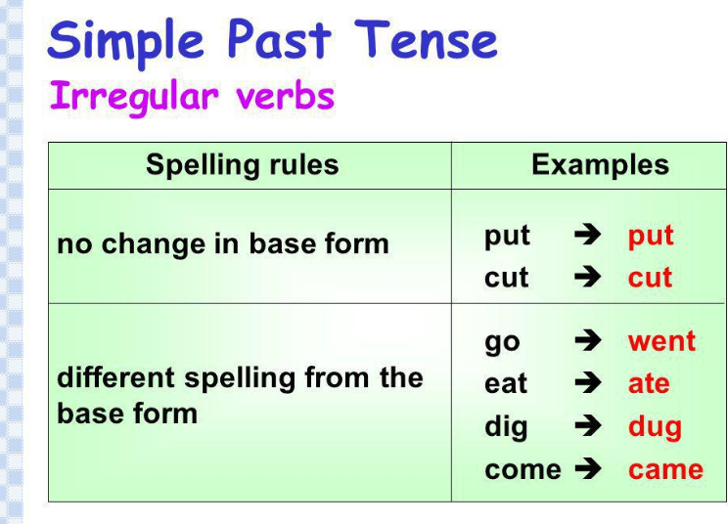

List of Irregular Verbs
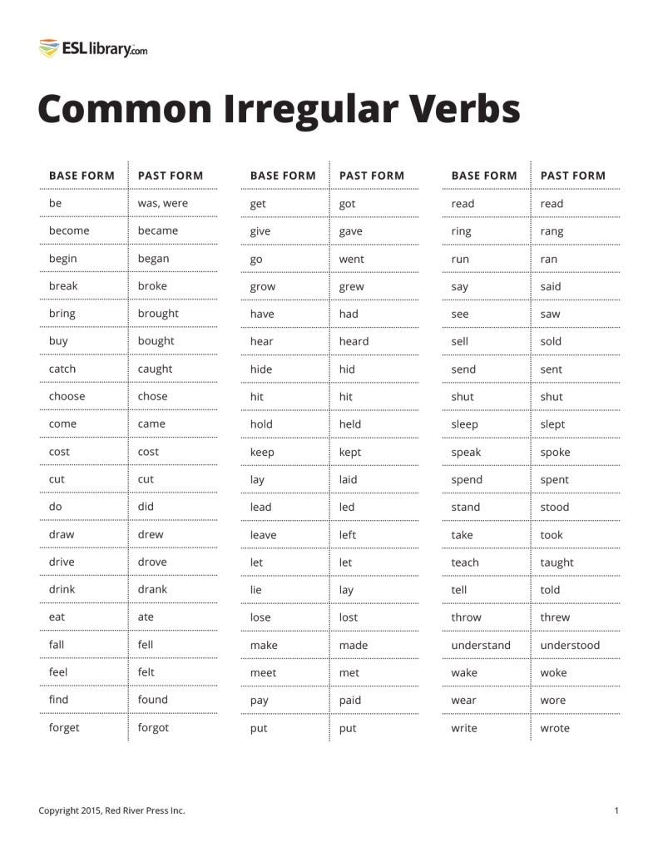

Grammar Rule

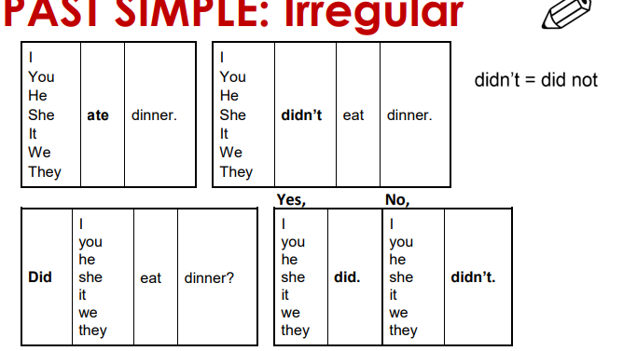

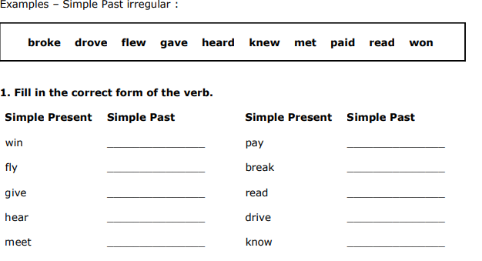

2. Change the following sentences into :
a)negative b) interrogative c) WH questions

Example :
We went to work by bus negative: We didn´t go to work by bus
Interrogative: Did we go to work by bus?
WH question: How did you go to work?

1. Peter came here yesterday …………………………………………………
………………………………………….......?
……………………………………………….?

2. I drank tea yesterday ……………………………………………….
………………………………………………?
……………………………………………..?

3. They saw a car accident ………………………………………………….
…………………………………………………?
………………………………………………….?

4. She went to the movies yestarday ………………………………………………
…………………………………………………?
…………………………………………………?

3.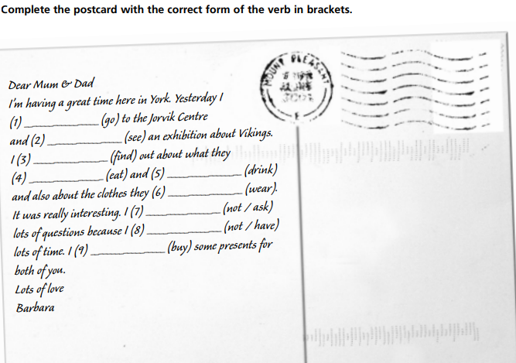

4.Reading Comprehension :

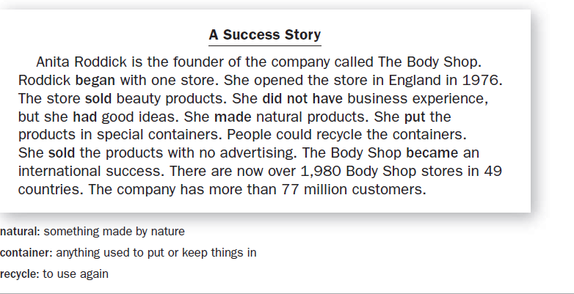

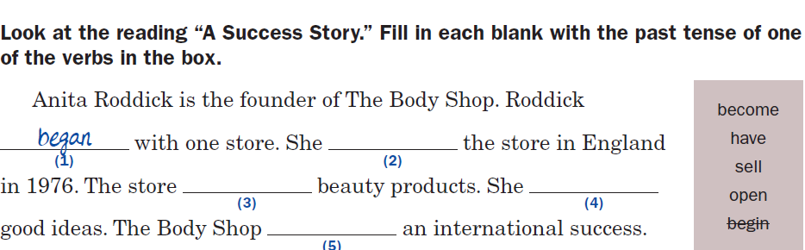

5. Writing activity.
Write a short biography of a succesful character you like most.

Escribe un párrafo sobre alguien famoso que tú admires , utiliza el tiempo pasado , empleando los verbos regulares e irregulares y las estructuras gramaticales repasadas en estas guías.

- Make up a story about the life of a succesful person you admire.
- Answer the questions like the following: What is the person ´s name?; When She / he born? ; Where she / he born? ;What things did she/he do in her/his life?; What is the the name of his bussiness?,How did he she become famous ? etc.

…………………………………………………………………………………………………………………………………………………………………………………………………………………………………………………………………………………………………………………………………………………………………………………………………………………………………………………………………………………………………………………………………………………………………………………………………………………………………………………………………………

